**Course Project   
DeVry University  
College of Engineering and Information Sciences**

**Course Number: CEIS236**

**Course Project Deliverable: 3**

**Part I: Tables Created:** Screenshot of tables below:

select * from customer;

select * from invoice;

select * from line;

select * from product;

select * from vendor;

**PART II:** Single table queries screenshots

Problem 1: Write the SQL code required to list the product code, description, and price from the product table. Take a screenshot of your results

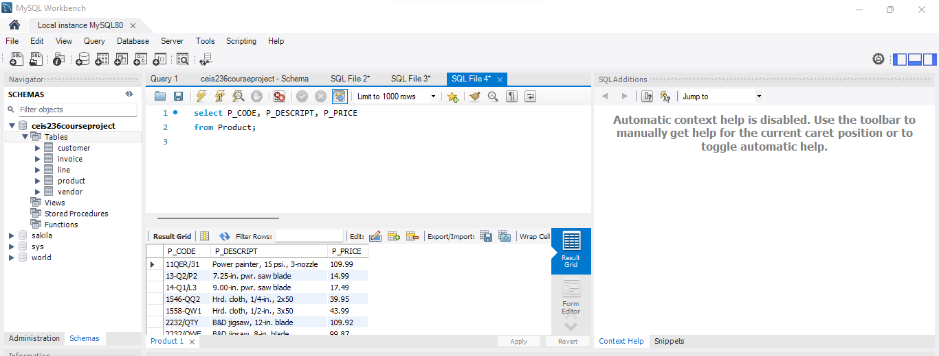

**select P_CODE, P_DESCRIPT, P_PRICE  
from Product;**

Problem 2: Modify the query above to only show those products that cost more than 20. Take a screenshot of your results.

**select P_CODE, P_DESCRIPT, P_PRICE  
from Product  
where P_PRICE > 20;**

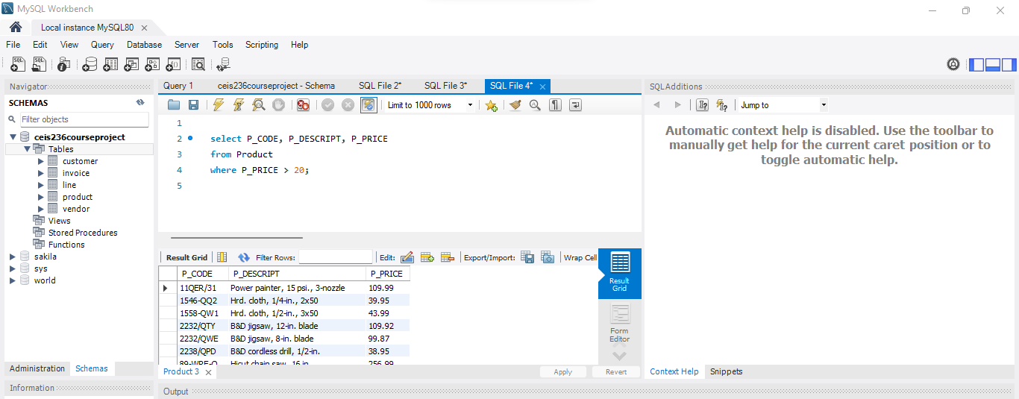

Problem 3: Modify the Problem 2 query above to show the results with price descending. Take a screenshot of your results.

**select P_CODE, P_DESCRIPT, P_PRICE  
from Product  
order by P_PRICE DESC;**

Problem 4: Modify the Problem 3 query above to show products that cost more than 20 and less than 100. Take a screenshot of your results.

**select P_CODE, P_DESCRIPT, P_PRICE  
from Product  
where P_PRICE > 20 and P_PRICE < 100;**

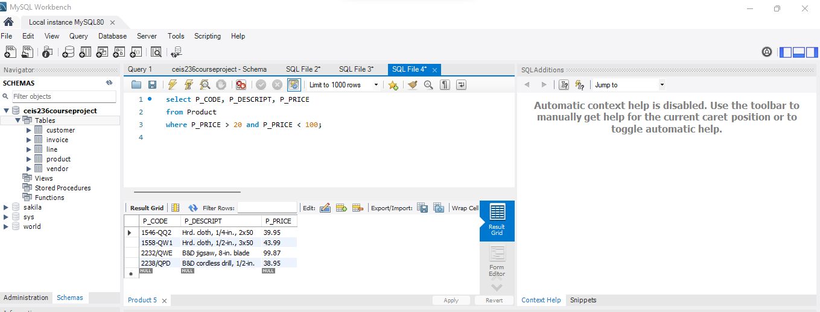

Problem 5: Write the SQL code required to list the first name and last name of all customers whose middle initial is G. Take a screenshot of your results (hint – you should get two names

SELECT CUS_FNAME, CUS_LNAME

FROM CUSTOMER

WHERE CUS_INITIAL='G';

Problem 6: Write the SQL code required to list the code, first name, last name, and balance of all customers whose last names begin with O. Take a screenshot of your results (hint: you should get 3 names)

SELECT CUS_CODE, CUS_FNAME, CUS_LNAME, CUS_BALANCE

FROM CUSTOMER

WHERE CUS_LNAME LIKE "O%";

Problem 7: Write the SQL code to list only distinct p_codes from the line table

SELECT DISTICNT P_CODE

FROM line;